Conference Venue:
Sheraton Suites Eau Claire, 255 Barclay Parade S.W., Calgary, Alberta

Wednesday, May 1, 2013

4:00 p.m. –  9:00 p.m. | Registration and Information Desk  Lobby, Sheraton Suites Eau Claire

Thursday, May 2, 2013

7:00 a.m. –  9:00 p.m. | Registration and Information Desk  Lobby, Sheraton Suites Eau Claire
Professional Staff Development Program - Navigating Roles and Relationships, the Secretary’s Challenge

8:00 a.m. – 9:00 a.m. | Breakfast  Wildrose South
9:00 a.m. | Keynote Address  Wildrose Centre  Knowledge Management: The GPS to Navigating Governance Roles & Relationships  Jim Pealow, MBA, CMA, CAE, CMC is a seasoned executive and has served as chief staff officer and chief volunteer leader in a number of associations. He is a writer, instructor/coach, author, speaker and consultant in not-for-profit association leadership and management.
10:30 a.m. - 10:45 a.m. | Break  Main Lobby
10:45 a.m. – 12:00 noon | Board Professional Staff Panel  Succession Planning for the Board Secretary  Wildrose Centre
12:00 noon – 1:00 p.m. | LUNCH  Wildrose South
1:00 p.m. – 1:45 p.m. | Managing Organizational Change at the Governance Level – Tools, Tips and Best Practices  Wildrose Centre  Moderator: Diane Davidson, University of Ottawa  Thematic Working Groups  - Building a relationship with your President  - Building a relationship with your Board Chair/Committee Chair  - Engaging your Board members  - Goal-setting with your Board
3:15 p.m. – 3:30 p.m. | Break  Main Lobby
3:30 p.m. – 4:00 p.m. | Working Groups Report Back on Themes
4:00 p.m. – 4:15 p.m. | Tear Drop Award
4:30 p.m. | Buses will be available to transport delegates from the Sheraton to the Calgary Zoo for the Opening Reception
5:00 p.m. – 6:30 p.m. | Opening Reception – Calgary Zoo
6:30 p.m. | Buses will be available to transport delegates from the Calgary Zoo to the Sheraton
7:00 p.m.  9:00 p.m. – 12:00 a.m. | Free Evening/Optional Dinners at Downtown Restaurants –  sign-up sheet available at the Registration/Information desk  Hospitality Suite  Willow
Friday, May 3, 2013

7:45 a.m. – 8:30 a.m. |  | Full Breakfast  Wildrose South
8:30 a.m. – 9:00 a.m. |  | Welcome  Wildrose North & Centre  - Jane O’Connor, CUBA Chair  - Richard Shaw, Chair, Mount Royal University Board of Governors
9:00 a.m. – 10:00 a.m. |  | Keynote Address:  The Force of the Future: Post-Secondary Education in Tomorrow’s World  Wildrose North & Centre  - Richard Worzel, Futurist  The world around and within post-secondary institutions is changing, and those changes will have dramatic effects and consequences on both the pedagogy within colleges and universities, and the ways in which university Boards will need to adapt and prepare for the future. Richard Worzel is a Chartered Financial Analyst, best-selling author, strategic planner, and Canada's leading futurist. In this presentation, he covers the key factors that will affect universities over the next 5-10 years, including:  - The purpose of a university education and degree.  - How the workplace will change.  - How students are changing.  - The aging of the population.  - Technology is about to revolutionize society, the workplace, and pedagogy.  In summary, this presentation will provide a roadmap of the landscape that university boards will face in tomorrow's world. As always, forewarned is forearmed.
10:00 a.m. – 10:30 a.m. |  | Break With thanks to    Main Foyer
10:30 a.m. – 12:00 noon | Concurrent Sessions  Concurrent Session I: Scenario Planning and Risk Management  Wildrose Centre  - Richard Worzel, Futurist  The future is inherently unpredictable; with at least some aspects of the future are certain to catch planners by surprise. Accordingly, rather than try to come up with a perfect prediction, planners should make use of this uncertainty and turn it to advantage by preparing for the most likely possible futures, also called scenarios. This workshop introduces the concepts of scenario planning, how to create scenarios, how to evaluate the ones worth pursuing, and how to prepare contingency plans for the most important ones.  Concurrent Session II: Academic Governance: Managing the Relationship between the Board and Senate (General Faculties Council [GFC])  Wildrose South  - Liz Watson, Founder, WATSON Inc.  Discussion on how to develop a healthy working relationship with the University Senate (GFC).
12:00 noon – 1:30 p.m. |   Lunch  Wildrose South  With thanks to
1:30 p.m. –  3:00 p.m. | Role of the Board in Today’s Governance Environment  Wildrose North & Centre  - Liz Watson, Founder, WATSON Inc.  In today’s environment, University Boards are more actively engaged in setting strategy, overseeing risk, overseeing succession and monitoring performance which is a different role than has been played at many universities in the past.  What is the proper role for the Board at a university and what is the line between governance and operations?
3:00 p.m.– 4:00 p.m. | Networking Sessions  - Board Chairs and Vice-Chairs [Wildrose Centre]  - Board Professional Staff [Wildrose South]
4:15 p.m. | First bus departs Sheraton Suites Eau Claire for Mount Royal University tour
5:00 p.m. – 6:00 p.m. | Tour of Mount Royal University
5:30 p.m. | Second bus departs Sheraton Suites Eau Claire for Reception and Banquet
6:00 p.m. | Bus departs Mount Royal University for Reception and Banquet
6:00 p.m. – 9:00 p.m. | Reception and Banquet - Wainwright Hotel, Heritage Park Historical Village  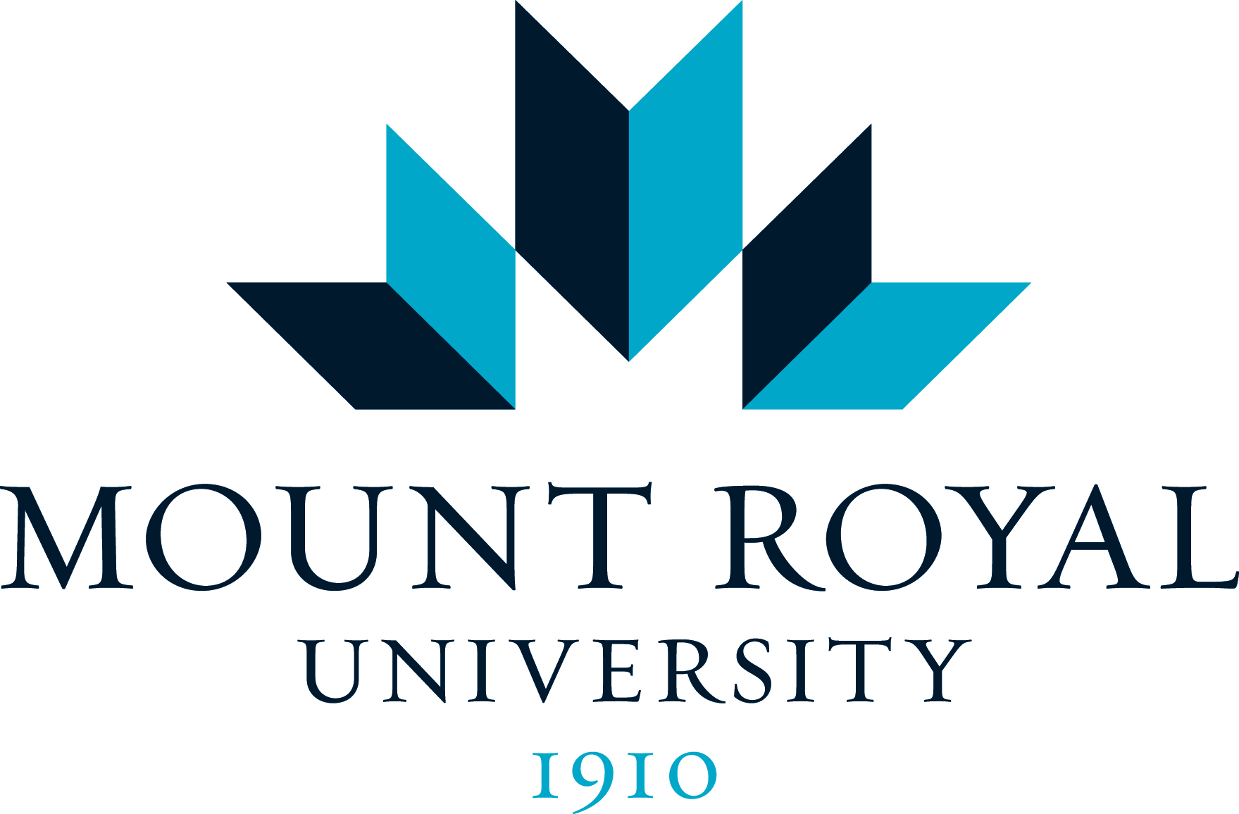  With thanks to [insert U of C Logo]
9:00 p.m.  9:00 p.m. – 12:00 a.m. | Buses depart Heritage Park for Sheraton Suites Eau Claire  Hospitality Suite  Willow

Saturday, May 4, 2013

7:00 a.m. –  12:00 noon | Registration and Information Desk  Lobby, Sheraton Suites Eau Claire
8:00 a.m. – 9:00 a.m. | Breakfast – Regional Roundtables  Wildrose South  Tables will be assigned by region. Board Members and Professional Staff are encouraged to sit with colleagues from your region to network and discuss common issues.
9:00 a.m. – 10:15 a.m. |  | The Future of Canadian Universities: Do Our Universities Need to be Rethought?  Wildrose North & Centre  - Ken Coates, Professor and Canada Research Chair in Regional Innovation, Johnson-Shoyama Graduate School of Public Policy, University of Saskatchewan  - Ian Clark, Professor, School of Public Policy and Governance, University of Toronto and co-author of “Academic Reform”  Ken Coates and Ian Clark discuss the future of Canadian universities focusing on the question of the extent to which government is needed to lead reform efforts.
10:15 a.m. – 10:30 a.m. |  | Break  Main Foyer
10:30 a.m. –  11:30 a.m. |  | The Future of Canadian Universities: Do Our Universities Need to be Rethought?  Wildrose North & Centre  Panel – Reaction to the Coates/Clark presentation  David Docherty, President, Mount Royal Univesity  Robert Giroux, Board Chair, University of Ottawa  Peter Meekison, Board Chair, Royal Roads University  Sarah Veinot, Board Chair, Mount Saint Vincent University
11:30 a.m. –  12:00 noon |  | CUBA Annual General Meeting  Wildrose North & Centre
12:00 noon –  12:30 p.m. |  | Presentation on CUBA 2014 and Conference Wrap Up  Wildrose North & Centre
12:30 p.m. |  | Lunch  Wildrose North & Centre

